**Lab Manual for Computer Communication and Networking**

**Lab No. 4**

**Virtual Private Network(VPN)**

**BAHRIA UNIVERSITY KARACHI CAMPUS**

**Department of Software Engineering**

**COMPUTER COMMUNICATION & NETWORKING**

**LAB EXPERIMENT # 4**

VLANs (Virtual LANs) and Trunks

**OBJECTIVE: -**

* This lab assignment helps in understanding how VLANs (Virtual LAN) and Trunks can be created on a Cisco switch.

**THEORY:**

**Virtual LAN (VLAN):**

A **virtual LAN**, commonly known as a **VLAN**, is a group of hosts with a common set of requirements that communicate as if they were attached to the [Broadcast domain](http://en.wikipedia.org/wiki/Broadcast_domain), regardless of their physical location. A VLAN has the same attributes as a physical [LAN](http://en.wikipedia.org/wiki/Local_area_network), but it allows for end stations to be grouped together even if they are not located on the same [network switch](http://en.wikipedia.org/wiki/Network_switch). Network reconfiguration can be done through software instead of physically relocating devices.

By default, a Cisco switch creates a VLAN called the Default VLAN 1. All the machines connected to the switch are in the default VLAN 1. It is required to split this by creating one more VLAN called VLAN 2. If you were designing a school, it would be nice to use a VLAN for teacher and a VLAN for students.

**NETWORK TOPOLOGY: -**

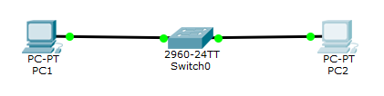

**PROCEDURE AND OBSERVATION: -**

Switch>en

Switch#config t

Switch(config)#hostname Switch

Switch(config)#vlan 2

Switch(config-vlan)#name Student

Switch(config-vlan)#exit

**(PC 2 is connected to port 2 on switch)**

Switch(config)#interface FastEthernet 0/2

Switch(config-if)#Switchport mode access

Switch(config-if)#Switchport access vlan 2

Switch(config-if)#exit

**(Show vlan configuration)**

Switch# show vlan brief

VLAN Name Status Ports

---- --------------------------------------------------------------

1 default active Fa0/2, Fa0/3, Fa0/4, Fa0/5

Fa0/6, Fa0/7, Fa0/8, Fa0/9

Fa0/10, Fa0/11, Fa0/12, Fa0/13

Fa0/14, Fa0/15, Fa0/16, Fa0/17

Fa0/18, Fa0/19, Fa0/20, Fa0/21

Fa0/22, Fa0/23, Fa0/24

20 students active Fa0/1

1002 fddi-default active

1003 token-ring active

1004 fddinet-default active

1005 trnet-default active

**Trunks:**

**VLANs** can be configured across multiple switches, but a separate port must be assigned for each **VLAN**. A better solution is configuring a **trunk** that can carry all assigned **VLANs** through one port saving all other ports.

**NETWORK TOPOLOGY: -**

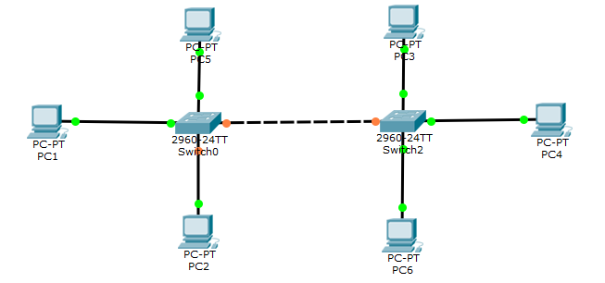

**PROCEDURE:**

Switch>en

Switch#config t

Enter configuration commands, one per line. End with CNTL/Z.

Switch(config)#int fa0/3

Switch(config-if)#switchport mode trunk

Switch(config-if)#switchport trunk allowed vlan 1-99

Switch(config-if)#end

**QUESTIONS: -**

1. **Connect 4 switches A, B, C and D, all switches must be password protected (encrypted password) and apply the following configuration, show network topology and configuration in your lab task.**
2. Switch B, C, D must be connected to switch A
3. Switch B with VLAN name Faculty & Students having 5 logical ports each
4. Switch C with VLAN name Management having 3 logical ports
5. Switch D with VLAN name SRC & NCMPR having 3 logical ports each
6. Choose network IP from Class B for LAN like 172.16.X.X for hosts to test your LAN network

**Output:**

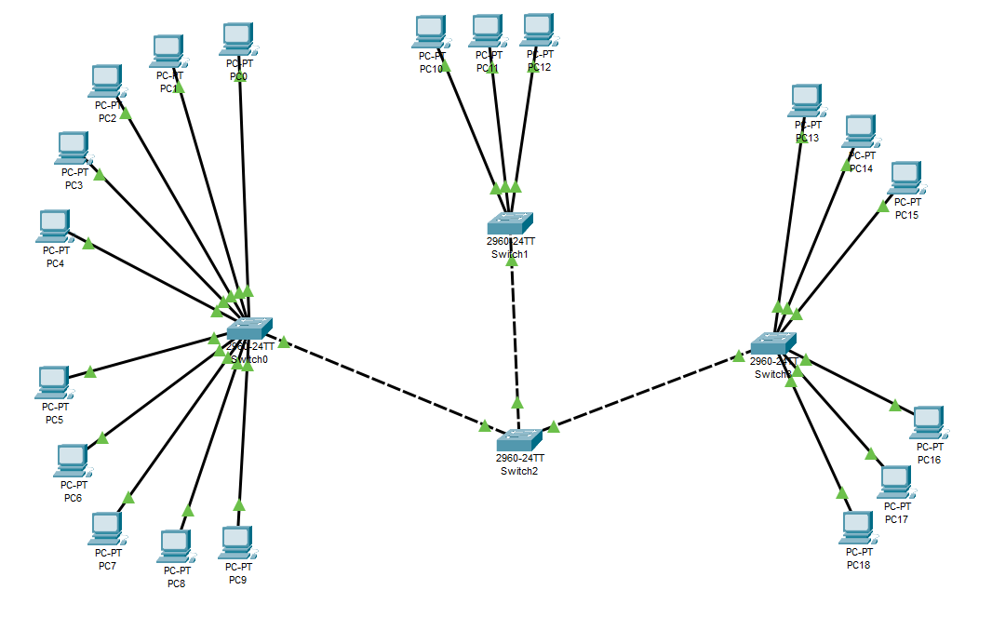

**Switches Password Encryption:**

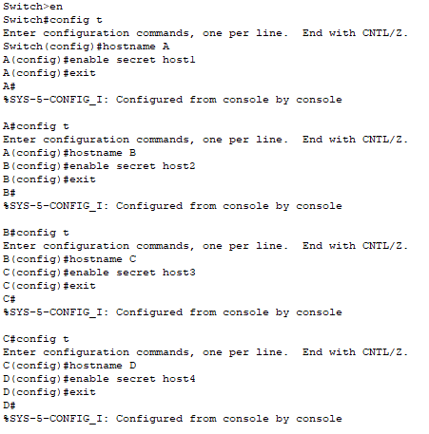





**Student and Faculty VLAN:**

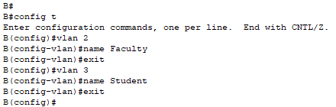

**Student:**

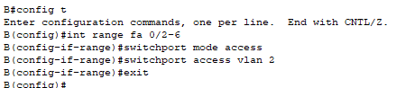

**Faculty:**

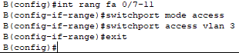

**Show (Switch B) VLANs:**

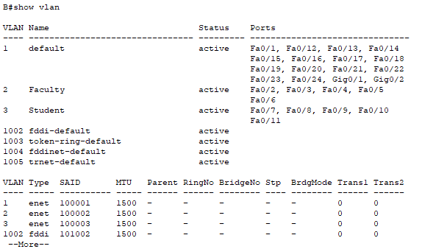

**Management VLAN:**

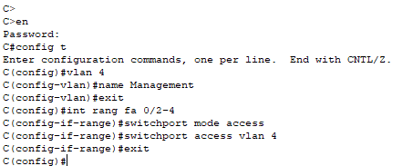

**Show (Switch C) VLANs:**

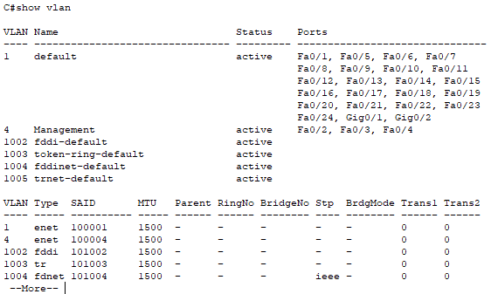

**SRC and NCMPR VLAN:**

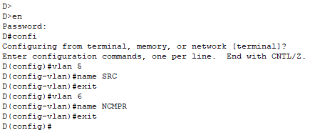

**SRC:**



**NCMPR:**

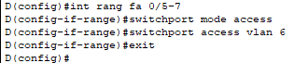

**Show (Switch D) VLANs:**

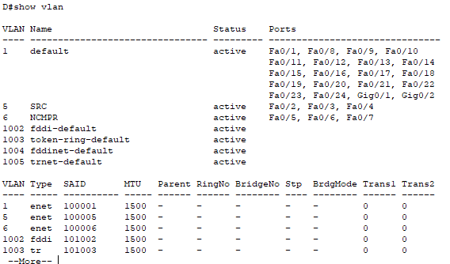

|  |  |
| --- | --- |
| **PC NO** | **IP** |
| 0 | 172.16.11.0 |
| 1 | 172.16.11.1 |
| 2 | 172.16.11.2 |
| 3 | 172.16.11.3 |
| 4 | 172.16.11.4 |
| 5 | 172.16.22.5 |
| 6 | 172.16.22.6 |
| 7 | 172.16.22.7 |
| 8 | 172.16.22.8 |
| 9 | 172.16.22.9 |
| 10 | 172.16.33.10 |
| 11 | 172.16.33.11 |
| 12 | 172.16.33.12 |
| 13 | 172.16.44.13 |
| 14 | 172.16.44.14 |
| 15 | 172.16.44.15 |
| 16 | 172.16.55.16 |
| 17 | 172.16.55.17 |
| 18 | 172.16.55.18 |

**PC0 from PC4 (no packet will lose because both PC’s are in same VLAN)**

**Result:**

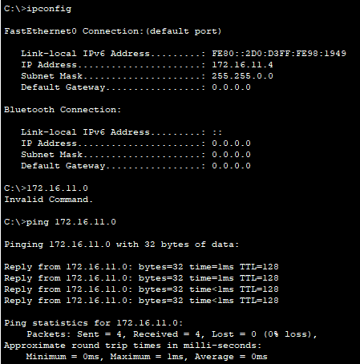

**PC4 from PC5 (packet will lose because both PCs are not in same VLAN)**

**Result:**

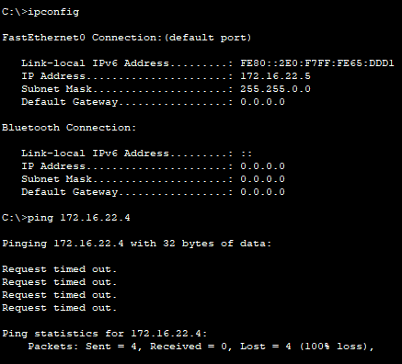

**TIME BOXING:**

|  |  |  |
| --- | --- | --- |
| **Activity Name** | **Activity Time** | **Total Time** |
| **Instruments Allocation + Setting up Lab** | 10 mints | 10 mints |
| **Walk through Theory & Tasks (Lecture)** | 60 mints | 60 mints |
| **Implementation & Practice time** | 90 mints | 80 mints |
| **Evaluation Time** | 20 mints | 20 mints |
|  | Total Duration | 180 mints |

**Teacher Signature**: ________________________

**Student Registration No**: ________________________